Software Requirements Specification

for

FastData

Version 1.0 approved

Prepared by Dev team

Dev team names

May 24th, 2023

Table of Contents

Table of Contents ii

Revision History ii

1. Introduction 1

2. Overall Description 2

2.1 Product Perspective 2

2.2 Product Features 2

2.3 User Classes and Characteristics 2

2.4 Design and Implementation Constraints 2

2.5 User Documentation 2

3. Use Cases 3

3.1 Use Case 1 3

3.2 Use Case 2 (and so on) 3

4. External Interface Requirements 3

4.1 User Interfaces 3

4.2 Software Interfaces 3

5. Nonfunctional Requirements 4

5.1 Performance Requirements 4

5.2 Safety Requirements 4

5.3 Security Requirements 4

5.4 Software Quality Attributes 4

6. Other Requirements 4

Appendix A: Glossary 5

Appendix B: Issues List 5

Revision History

|  |  |  |  |
| --- | --- | --- | --- |
| **Name** | **Date** | **Reason For Changes** | **Version** |
|  |  |  |  |
|  |  |  |  |

# Introduction

FastData: Simplified Data Collection and Visualization Made Fast and Easy

# Overall Description

## Product Overview

FastData is a powerful and accessible software tool designed to revolutionize the way data collection and visualization are approached. This user-friendly solution empowers individuals of all skill levels to effortlessly create databases and generate visually stunning representations of their data without the need for advanced Excel or statistical expertise.

## Product Features

1. Lightning-Fast Data Collection: FastData offers a streamlined and efficient data collection process, eliminating the complexities often associated with traditional spreadsheet or database management systems. Users can input data quickly and easily, saving valuable time and effort.
2. Instant Visualization: Say goodbye to tedious manual charting. FastData automatically transforms collected data into visually appealing charts, graphs, and diagrams in real-time. Instant visualization allows users to gain insights at a glance and communicate their findings effectively.
3. Simple and Intuitive Interface: With a clean and intuitive interface, FastData ensures that users can navigate the software effortlessly. The user-friendly design caters to beginners while offering advanced functionality for experienced data analysts.
4. Customization Made Easy: FastData provides a range of customization options, allowing users to personalize their visualizations to match their specific requirements. Customize chart types, colors, labels, and other visual elements to create stunning, professional-grade outputs.
5. Accessibility for All: FastData aims to make data exploration and analysis accessible to everyone. By eliminating the need for extensive statistical knowledge or complex software skills, it empowers individuals from various backgrounds to harness the power of data and make informed decisions.

## User Classes and Characteristics

The primary user class is the End User, which may include students, business professionals, researchers, or simply someone interested in exploring data.  
There is no need for Admin User nor Dev User classes.

## Design and Implementation Constraints

There is no budget for possible expenses for this project. Possible expenses may arise when deploying project through Azure or some other service.   
Here is an article about Free Web App Hosting On Azure:  
<https://www.c-sharpcorner.com/article/free-web-app-hosting-on-azure/#:~:text=In%20this%20article%2C%20you%20will,application%20on%20Azure%20for%20free.&text=Primarily%20Azure%20is%20known%20for,free%20of%20cost%20for%20life>.

Looks like Azure free option limits to 1gb storage and doesn’t allow for custom domains. GitHub Pages may be a better option than Azure.

## User Documentation

A video demo will be available on YouTube as well as embedded user manual in a hamburger menu on the landing page.

# Use Cases

## Use Case One EX

* Actor: User / Admin / CEO / Debugger
* Story:
  1. Numbered steps

# External Interface Requirements

## User Interfaces

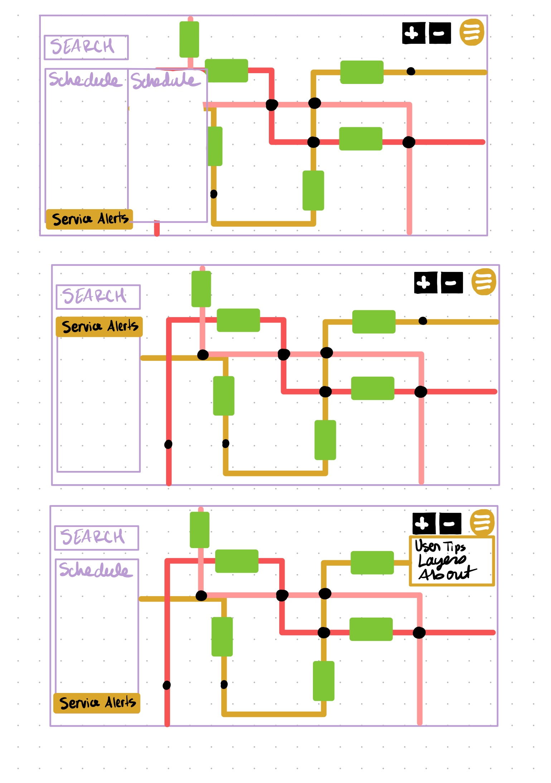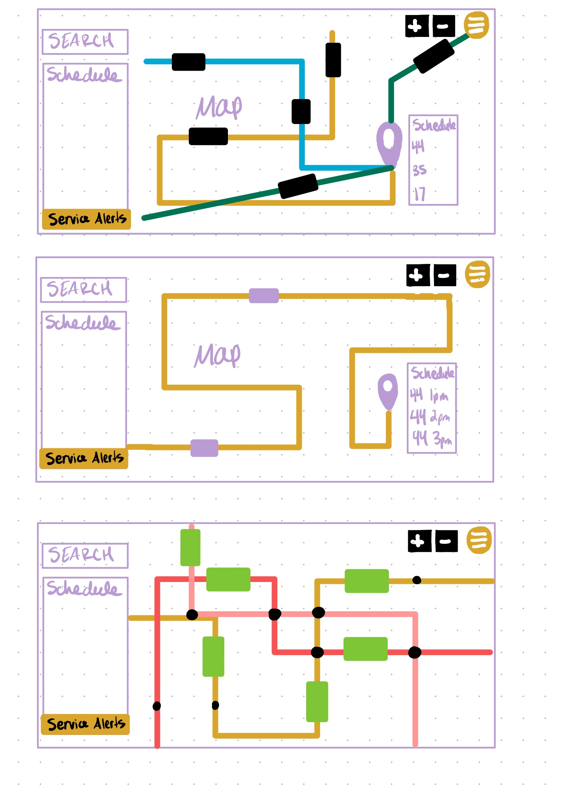

## Software Interfaces

# Nonfunctional Requirements

## Performance Requirements

## Safety Requirements

## Security Requirements

## Software Quality Attributes

# Other Requirements

Appendix A: Glossary

Appendix B: Issues List